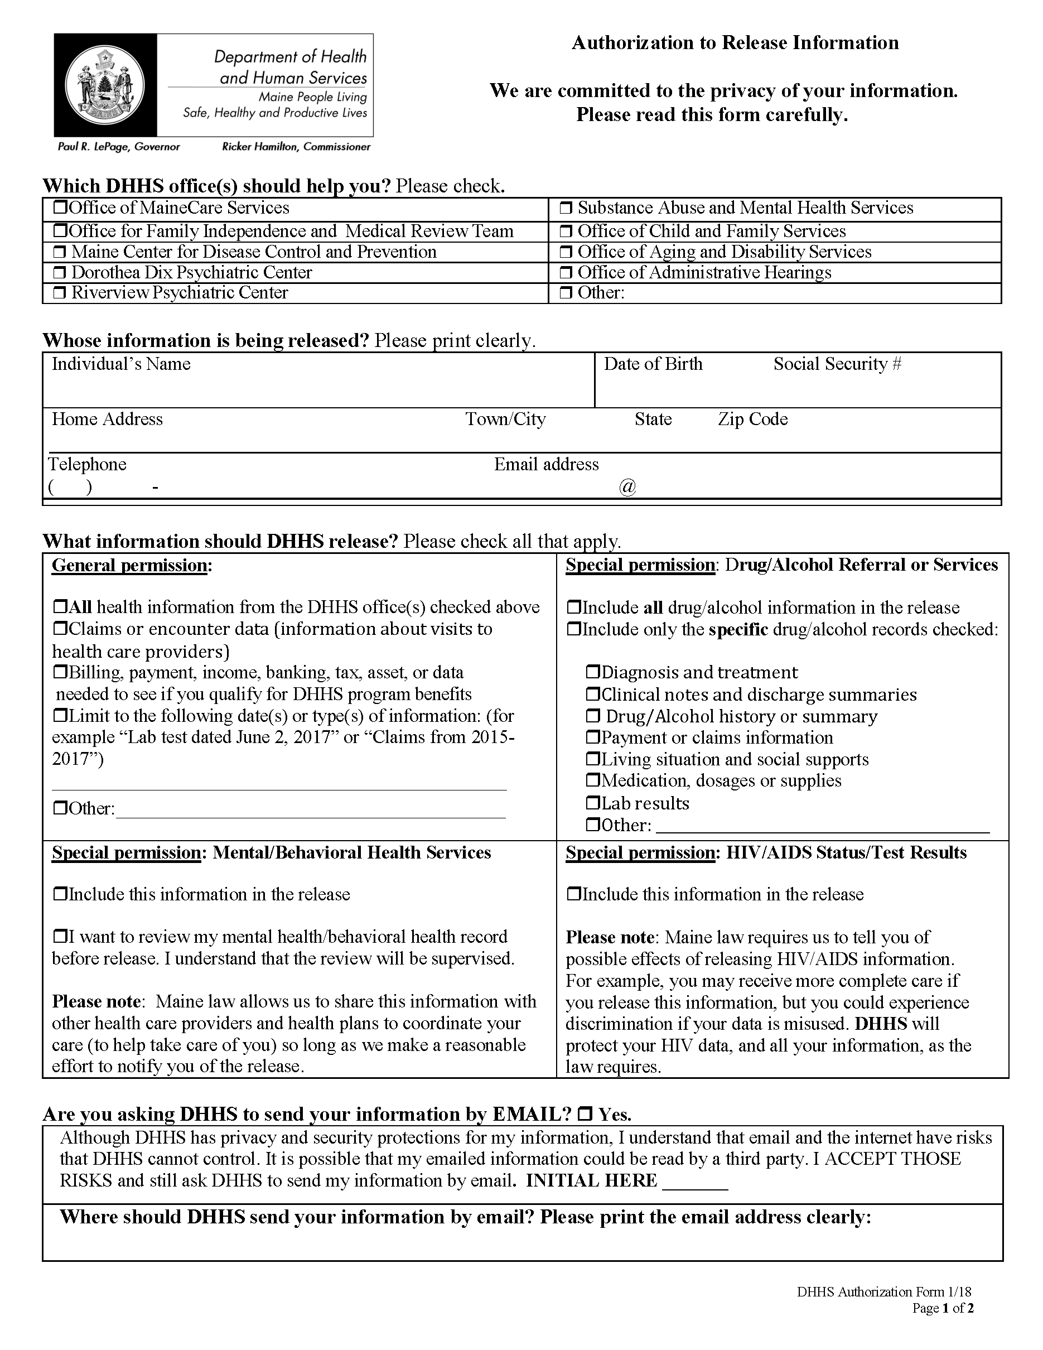
Batman
01/01/1979
xxx-xx-5555
Secret Location
Gotham
NJ
FROM 01/01/1979 TO PRESENT: Any and all MEDICAL RECORDS, including but not limited to patient history form(s), reports, etc. pertaining to Batman SSN: xxx-xx-5555, DOB: 01/01/1979.
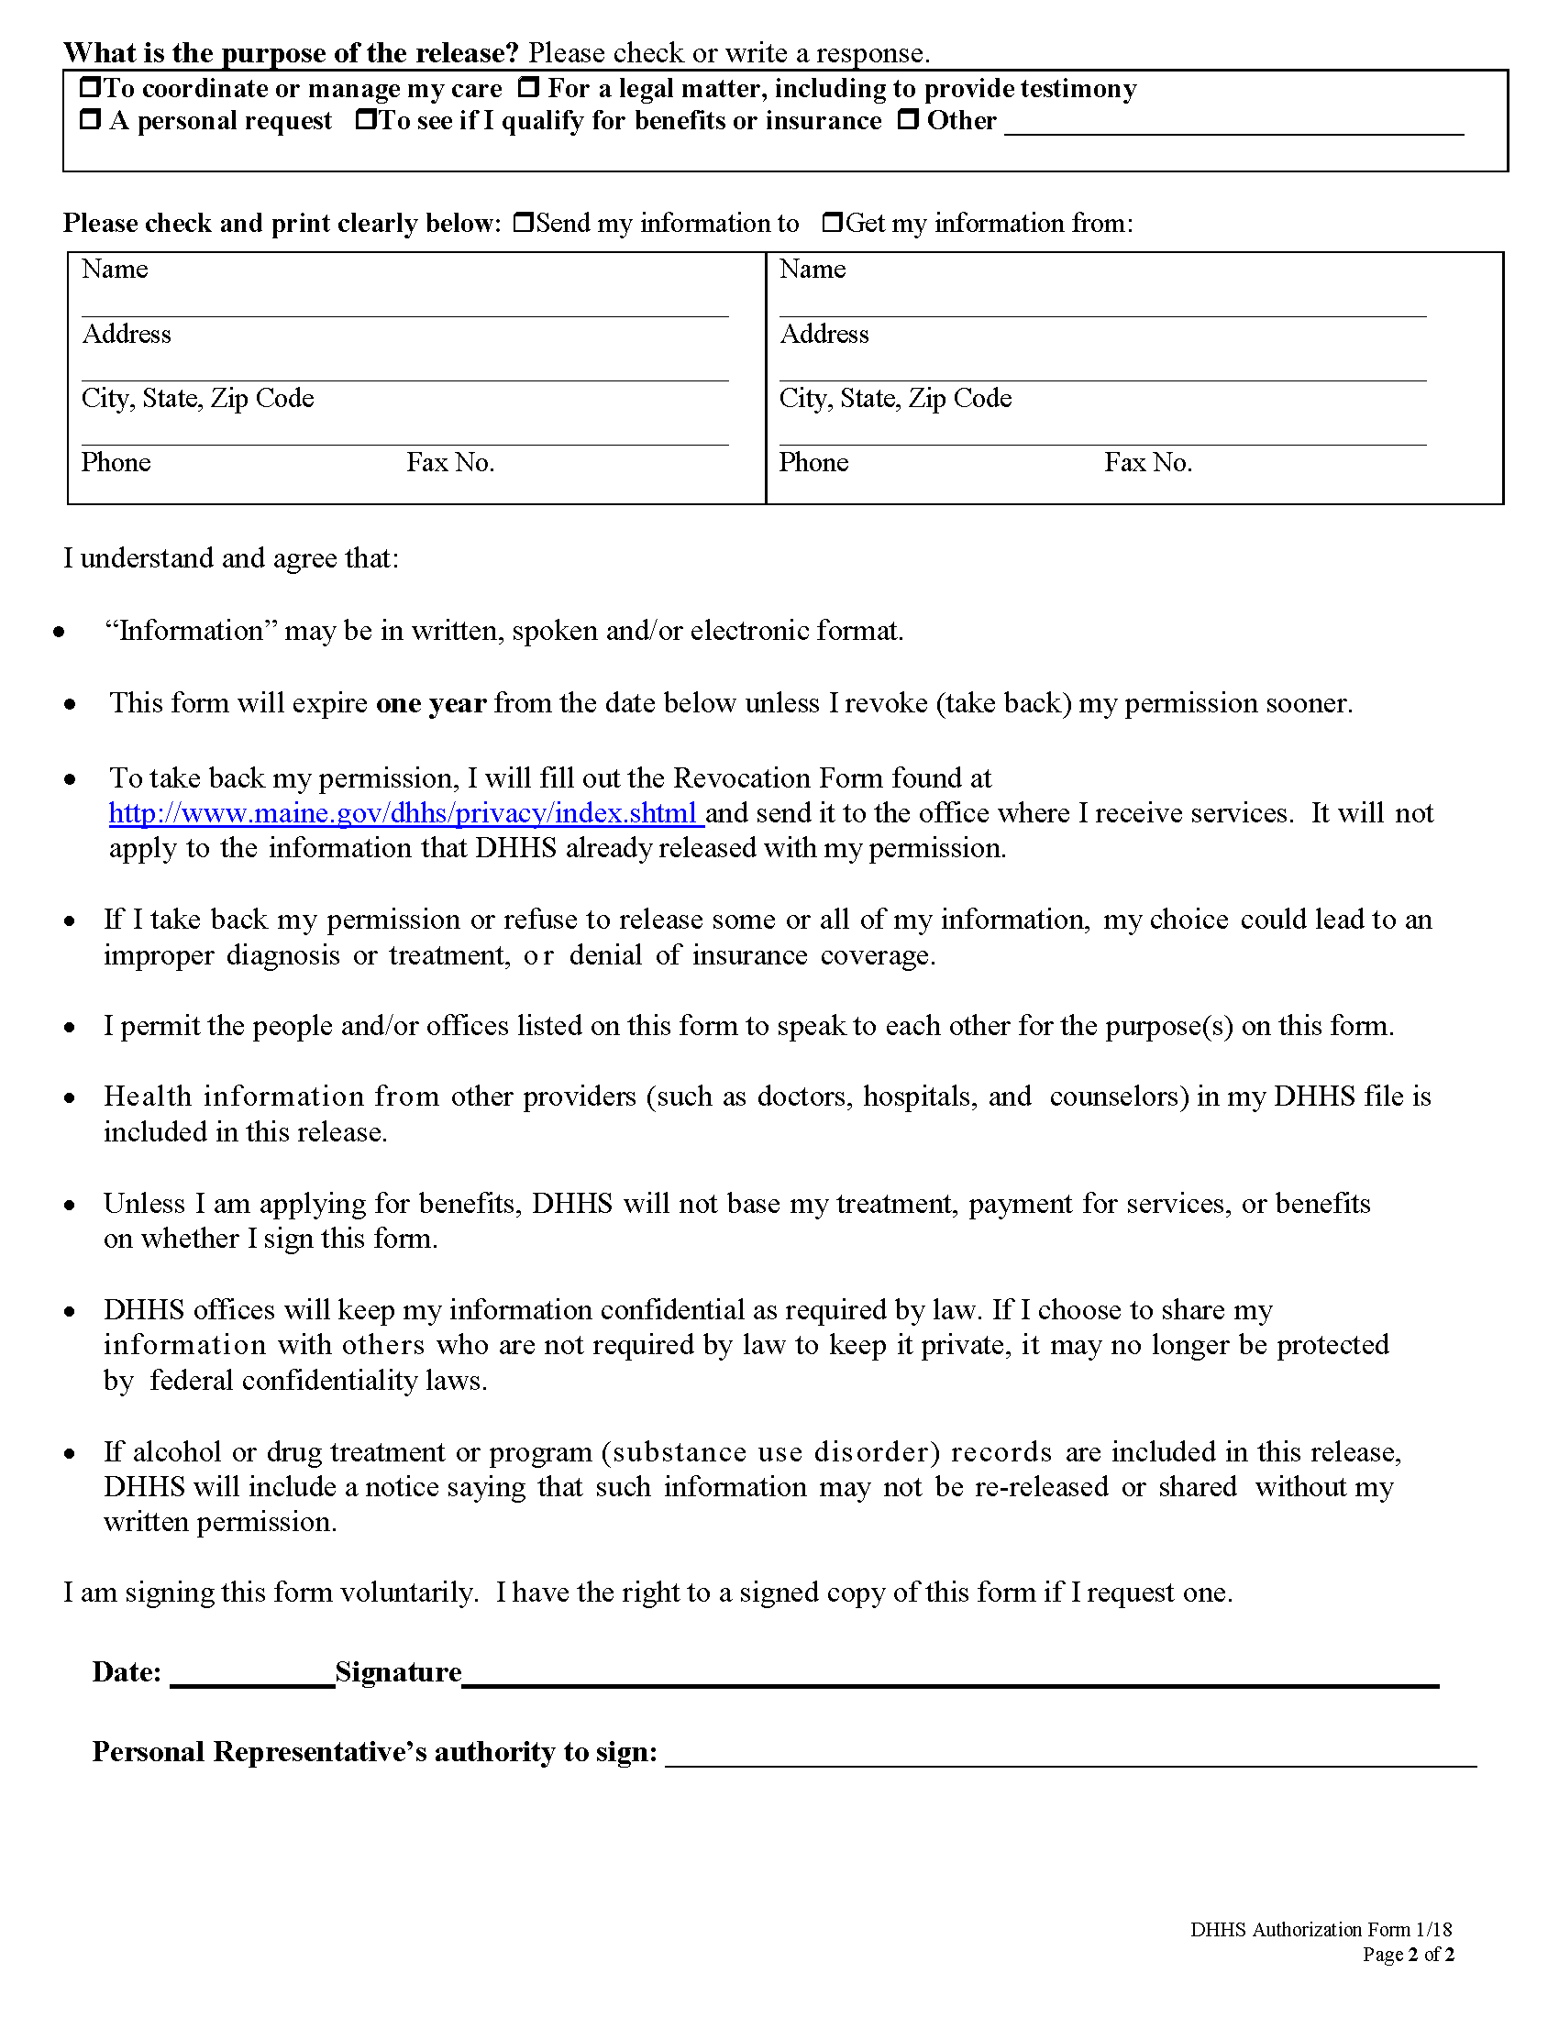
Axiom Requisition Copy Service

2869 Jolly Road

Okemos, MI 48864

X
(877) 886-5090 (517) 886-4116
X

